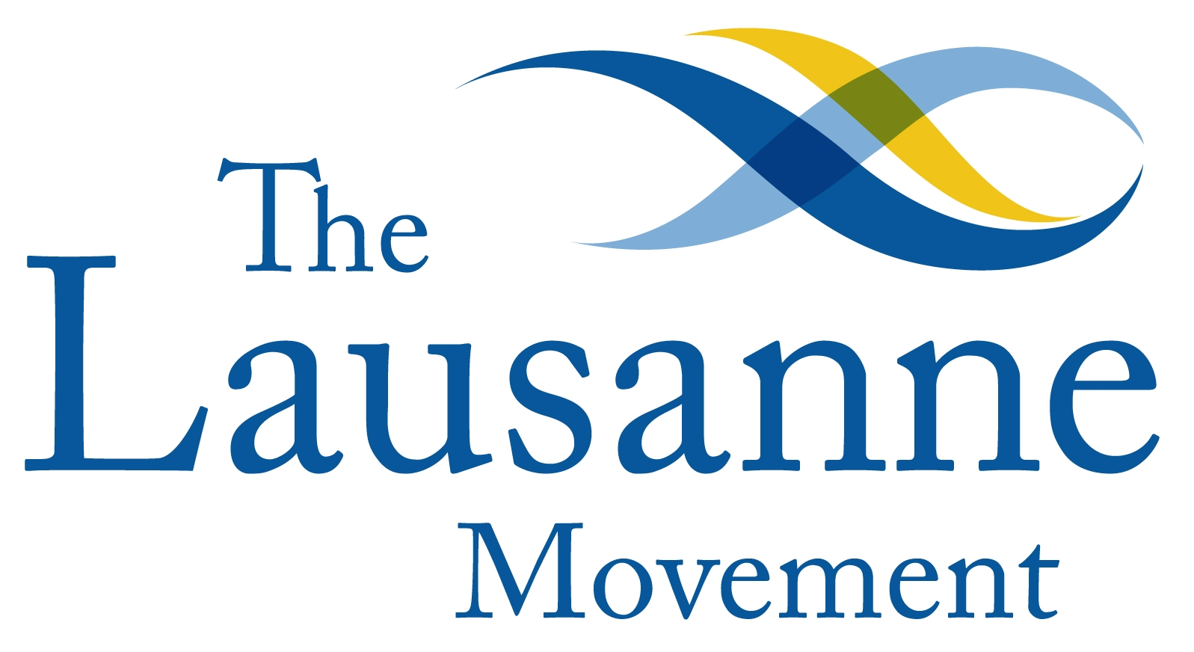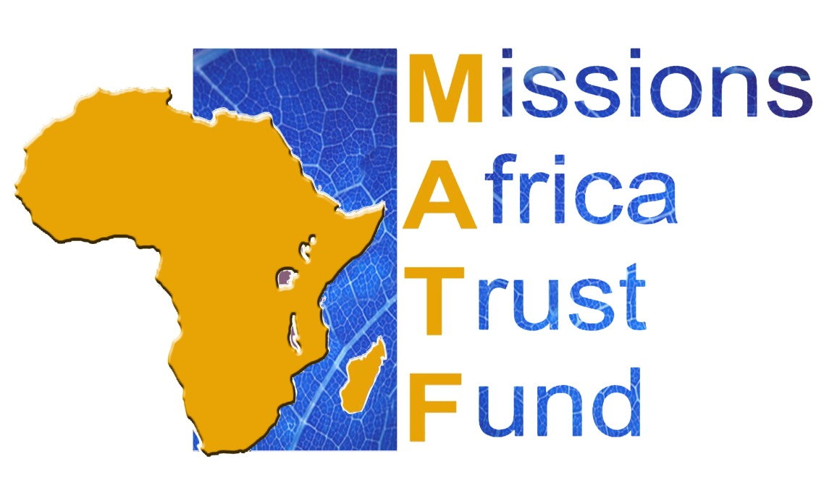
Missions Africa Trust Fund
Global Generosity Network and Lausanne Africa leaders launch MATF Virtual mission Think-Tank on Mission Giving in Africa

Africa has moved from a missionary receiving continent to a missionary sending continent. The time has come for the African church to become a mission giving church.

“As the heavens are higher than the earth, so are my ways higher than your ways and my thoughts than your thoughts. As the rain and the snow come down from heaven, and do not return to it without watering the earth and making it bud and flourish, so that it yields seed for the sower and bread for the eater, so is my word that goes out from my mouth: It will not return to me empty, but will accomplish what I desire and achieve the purpose for which I sent it.” (Isaiah 55:9-11 NIV)

"At least two thirds of the world's Christians now live in the continents of the global south and east. This reflects an enormous shift in world Christianity in this century since the Edinburgh Missionary Conference in 1910. We rejoice in the amazing growth of the Church in Africa" (Cape Town 2010 Commitment, p.7).

God is at work in challenging the African Church to become a 21st Century 'Macedonian' example of a mission giving Church - as Africa moves from a 'missionary receiving' to 'missionary sending' continent. We are passionate to see this vision become a reality in spite of the current situation. The MATF as focused African mission giving initiative could be a suitable platform to achieve this vision. The Global Generosity Network and Lausanne Africa leaders had to postpone a think-tank on the Missions Africa Trust Fund (MATF) that was to be held from 27-30 October 2014 in Ghana. This decision was made when the Ghanaian government placed a ban on all international conferences held in the country for the next 3 months due to the outbreak of the Ebola virus. God in His Sovereignty is turning this out to be another opportunity for us to even engage in wider and deeper ways!

We hereby announce the launch of the MATF virtual think-tank on mission giving in Africa. We invite Christian leaders from Africa and globally to participate in the strategic Think Tank to share, encourage, synergize and contribute to a movement of growing exemplary mission giving Churches from Africa. The virtual think-tank is a direct response to the challenge of Third Lausanne Congress on World Evangelization in Cape Town 2010 and the Cape Town Commitment.

You can participate and contribute to the MATF Virtual Think Tank in the following ways:
- Reflections on mission giving in Africa: This is being compiled and will be distributed for further consultation and discussion. African Christian leaders and interested leaders from outside the continent are welcome to send reflections which should be a page in length. The reflection from Rev Dr Siegfried Ngubane is an example of what is looked for. Please send contributions to Dr. Sas Conradie at ggncoord@gmail.com if possible by 20 October.
- The Africa Mission Giving Survey: This will give an indication of the need for and potential of African mission giving initiatives. We will appreciate if Christian leaders could complete the survey by 30 September.
- An electronic African Mission Giving Bulletin: This will give insightful mission focused prayer requests, news, articles, stories, initiatives, ideas, events and training opportunities on mission giving in Africa. Contributions could be sent to Dr Conradie and Nana Yaw Offei Awuku.
- An online discussion forum on mission giving in Africa: Send comments and participate in the LinkedIn discussion.

Dr Sas Conradie
Coordinator Global Generosity Network
ggncoord@gmail.com; Skype: sas.conradie; Tel. +44 20 8770 9717/+44 1825 768252
Nana Yaw Offei Awuku
Lausanne International Deputy Director, EPS Africa
nyoffeiawuku@lausanne.org; Tel. +233244650280; Skype: nana.yaw.o.awuku

