**Four Major Changes in Global Prosperity**

by Nathan Gamester  |   1:00 PM October 30, 2013

<http://blogs.hbr.org/2013/10/four-major-changes-in-global-prosperity/>

It was Abraham Maslow who [gave us](http://books.google.com/books?id=3_40fK8PW6QC&printsec=frontcover#v=onepage&q=hammer&f=false) that famous observation — “when the only tool you have is a hammer, everything looks like a nail.”  We all understand the implication: Anyone attempting to solve an ambiguous problem should start out in possession of a broad set of tools.

It is curious, then, that we continue to fall into the trap of reaching for one dominant tool for measuring the success of nations –- a narrow gauge of economic growth — and believing that the fixes it suggests are the one way to achieve progress.

Of course economic success is important –- most obviously in providing citizens with the things that make life better (healthcare, education, etc.) -– but only up to a point. Wealth alone does not make for a happy and successful society. Measuring success based solely on wealth, therefore, misses the many nuances of human wellbeing. National prosperity should be defined as much by human freedom, sound democracy, vibrant society, and entrepreneurial opportunity as it is by a growing economy.

Over recent years, governments too have increasingly begun to realize that focusing on GDP growth alone does not necessarily lead to improvements in living standards of their citizens. Put simply, what’s good for increasing GDP may not be good for the long-term betterment of society. The outcome of this is the realization that what we measure needs to catch up with what we value.

Over the last seven years, the Legatum Institute has been at the forefront of this “beyond GDP” discussion. Our annual [Prosperity Index](http://www.prosperity.com/) –- the 2013 edition of which we released yesterday –- measures national prosperity based on eight core pillars that combine “hard” data with survey data. The result is the most comprehensive assessment of national prosperity of its kind.

This year the Prosperity Index offers five consecutive years of comparable data. The world has changed a lot over the last five years, and events have occurred that changed the course of history for millions of people — the financial crisis of 2008, the Arab Spring, and the ongoing civil war in Syria, to name just a few.

In assessing national prosperity, considering trends over five years of data allows us to step back from the twists and turns of specific circumstances and, instead, consider the general direction of travel. And so what do we observe from this vantage point? Here are four observations that stand out.

**Global Prosperity is Rising.**Despite the tumultuous events of the last five years, global prosperity is actually still on the rise. This is driven by big technological advancements, as more and more people gain access to infrastructure vital for commerce and entrepreneurship to thrive. Also driving global prosperity are huge advancements in global health (especially across sub-Saharan Africa). For example, life expectancy in sub-Saharan Africa has risen by more than three years just since 2010.

**Latin America is Rising.**The Prosperity Index shows that Latin America is a region on the rise, demonstrating steady economic growth. Countries such as Mexico, Brazil, Chile, and Panama perform well on economic measures. In fact, in the last five years, every single country in Latin America and the Caribbean (with the exception of Jamaica) has improved its economic performance in the Index.

**Europe’s Loss is Asia’s Gain.**The trend from Latin America adds to a wider observation that a new economic order is emerging. As many Western countries – predominantly European countries – have fallen from being among the top-performing economies in the world, they have been replaced at the top by Asian countries. Malaysia, China, and Thailand now rank among the top 15 countries on economic measures, occupying rankings that, five years ago, were held by countries such as Denmark, Finland, Netherlands, and Ireland.

[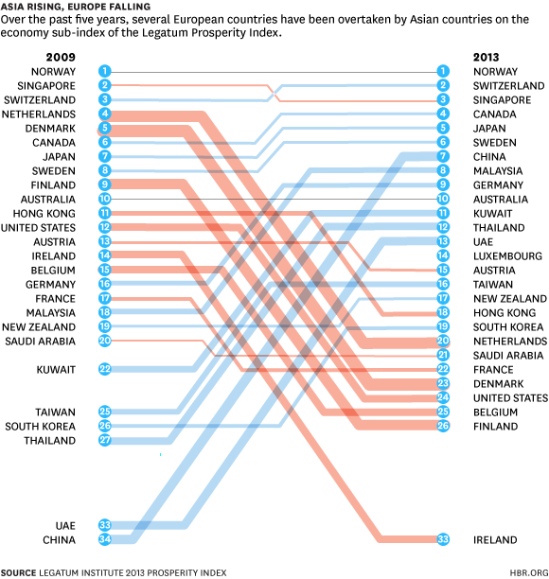](http://hbrblogs.files.wordpress.com/2013/10/asia_rising_ef.gif)

**Bangladesh overtakes India.**For the first time, Bangladesh has overtaken India, ranking 103rdoverall, compared to 106th for India. The two countries have been moving in opposite directions since 2009. India has fallen down the rankings on six of the eight pillars of prosperity, while Bangladesh has improved its position on six of the eight. India has declined most dramatically in Safety & Security, the Economy, and Governance. The data show that Bangladeshis live longer, healthier, and safer lives than their Indian counterparts.

Using a broad framework for measuring success allows for a clear-eyed understanding of the factors that both promote and restrain prosperity. This – to borrow Maslow’s terminology – provides the policymaker with tools beyond just a hammer with which to fix problems.

The path to prosperity for nations is complex. The history of human progress reveals a wide array of factors that combine to propel nations forward on their journey of development. The precise combination and ordering of these elements may be debated and questioned, but the truth remains: national progress – much like human progress – is comprised of a complex blend of different factors.

The Prosperity Index, much like Maslow’s most famous contribution (the [hierarchy of needs](http://en.wikipedia.org/wiki/Maslow's_hierarchy_of_needs)), attempts to provide a framework to understand and measure some of the most important factors that drive progress and development.