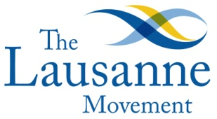 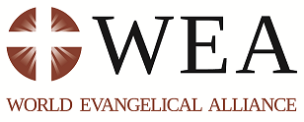

**Global Generosity Network**

**Four day ministry fundraising training**

* Main trainers - Rob Martin (First Fruit Institute) and Barbara Shantz (TWR)
* Length - 16 hours over 4 days
* Training structure - 30 minute segments divided between presentation, guided discussion and Q&A and breaks
* Training presentations via Skype with a local facilitator. The facilitator is a person who organises the training, invites participants, introduces material, manages discussion and functions as link person after training. Preferably the facilitator will have some understanding of fundraising.
* Venue decided upon by local facilitator and trainers
* Training manual sent before the time to translate into local language. The facilitator goes through the manual and other material before the time to get acquainted with the training.
* Training follow up plan of action agreed upon between facilitator and trainers
* Training outline
  + Day 1. Introduction and setting the stage
    - Two Questions
    - Biblical Stories
    - The Three Questions
  + Day 2. Indigenous fundraising
    - Four  Eras of Modern Mission funding
    - Biblical Fund Raising
    - Ministries Are Started to Solve Problems
    - The Orbit and The Pyramid
    - The Visionary and The Board
    - Accountability Structures
    - Practicalities
  + Day 3. Donor Motivation
    - Character
    - Track Record
    - Purpose
    - Idea
    - Communion of Giving and Receiving
  + Day 4 Proposals and putting it all together
    - Proposals
    - Putting It All Together
    - Next steps

For more information contact:

Dr Sas Conradie

Coordinator Global Generosity Network

P.O. Box 43; Sutton, Surrey; SM2 5WL; UK

Tel: +44 7729404594, +44 1825 768252

E-mail: [ggncoord@gmail.com](mailto:ggncoord@gmail.com); Skyp: sas.conradie

Website: www.generositymovement.org