Biblical Stewardship and Resource Development
Zenet Maramara, D.Min.
zenet.maramara@gmail.com

BIBLICAL STEWARDSHIP AND RESOURCE DEVELOPMENT

LEARNING TASKS

- Discover what the Bible teaches about stewardship
- Gain a fuller perspective of the biblical concept of stewardship
- Relate how the concept applies to all of life with particular focus on fundraising

GROUP WORK

- Form groups of 3-4 groups and discover what these Bible verses teach about stewardship.
- the concepts learned. Is there a theme that emerges?

Group 1
- Genesis 1:11
- Job 41:11
- Psalm 24: 1
- John 1:3.
- Psalms 104:25,30.
- Colossians 1:16-17.
- Psalm 50:10
- I Chronicles 29:1-19
- Lev. 25.23
- Haggai 2:8

Group 2
- Psalm 96:10-13.
- Isaiah 43:20-21
- Deut. 32:1-2
- Job 37:14-18
- Psalms 104:25, 27
- Matt 6:26

Group 3
- Psalm 19:1
- Isaiah 55:12-13
- Nehemiah 9:6
- Psalm 8:3-8
- I Chron. 16:7,30-34
- Rev 5:13
- Job 9:5-10

Group 4
- 1 Corinthians 4:2
- Matthew 6:19-21; 33
- Matthew 25:14-30 (see also Luke 19:12-27)
- Matthew 14:13-21 (see also Mark 6:30-44, Luke 9:10-17, John 6:1-14)
Luke 16:1-13

Summary of A Fuller Vision of the theological and biblical concepts of Stewardship
- Man as representative of God has to carry out God’s intents and purposes for creation
  - To bring him glory (a steward understands who God is: knows the doctrine of God and theology of the steward)
  - For all people to enjoy creation (social justice , equity, accountability, for society’s benefit particularly the poor and the needy
  - To serve creation, to serve society
(people, planet, public square)
For the Christian: an intense engagement with the broken world

- A steward participates in God’s continuing work of creation, sustenance, redemption. Redemption is cosmic and not limited to salvation of souls. A fuller vision of biblical stewardship involves care for creation and engagement in public life.
- As God’s representatives, a Christian steward cares for the earth, redeems culture and structures of society
- The steward is the prophetic voice that brings God’s truth to bear upon all areas of life
- There is no sacred-secular, no private-public divide

- A steward redeems culture by engaging in the public arena
- Steward is socially responsible and intentionally transformational
- Need for public theology to shape structures and policies of public life
- Lead a responsible economic life in society and the world
- Steward of public life

Biblical Stewardship
Framework for Christian Fundraising

“The earth is the Lord’s and everything in it, the world and all who live in it.”
Psalm 24:1

Guiding Principles in Christian Fundraising
- Divine ownership
- Human Stewardship
  - Christian Fundraising is based on biblical stewardship
  - God is the owner of all wealth
  - Christian fundraising is providing opportunity for people to partner with His work and Kingdom building

The biblical concept of stewardship
- Begins with knowing who God is
- Who we are in relationship to God
- How we respond to God’s calling and grace

Theology of the steward belongs to Christian ethics
- Calling of the steward
- Response of the steward
Who is a steward?
Who we are and whose we are
After the “who” question comes the practice, how we are to live?
Why have we failed to raise up stewards?
Emphasis on doing before the being
How we should live follow what we believe.
By definition a steward is under the command of the one who owns the resources that are to be stewarded.
God’s Kingdom
Children of God
Who is this God, in whose kingdom we live?
Whose children are we?
To whom are we to be stewards?

Four levels of a steward’s relationship
- Steward and owner
- Steward who cares for the resources of the owner and those for whom the resources are stewarded
- Relationship between the steward and the steward’s own needs
- Relationship between the steward and the resources themselves.

Biblical Stewardship

Definition
“handling with integrity the resources of another”
Debunking the myth of two-kingdom mentality
The kingdom which is “ours” and the kingdom of God

God is the owner
- God created all things. ”In the beginning created the heavens and the earth.”
Gen. 1:1 He never transferred the ownership of His creation to people.
- God owns all the land: “The land must not be sold permanently, because the land is mine.” Lev. 25:23
- God owns the silver and the gold: Hag. 2:8

God is the owner
- God’s responsibility: Provision
- Man is a steward
- Man’s responsibility: Faithful stewardship
- (knowledge of God, obedience, justice, righteousness, love of God and neighbor)

What is stewardship?
- “The earth and the fullness thereof” belongs to its creator, who made humankind in the divine image, to represent God’s ownership in the world, to exert dominion in justice, and to enjoy the world’s wealth by accepting it as common possession of all humanity. “
William Swartley, in The Earth is the Lord’s
IMAGE OF GOD
- Representation
- Representative

STEWARDSHIP IN THE OLD TESTAMENT

- Covenant Relationship with God
(Genesis 25:17,37) God is owner of all created order (Gen. 1; John 1: 1-3; Psalm 24: 1-2; Psalm 50:10-12)
- Emphasis on the land
- God’s Justice (Deuteronomy. 15 1:6)
- Jubilee-release from debts and bondage to debtors Deuteronomy. 15 1:6)
- Social Legislation-the rights of the poor and the powerless (Genesis 25:17,37.)

Stewardship in the New Testament
- Jesus fulfills the Sabbath and the Jubilee
(Isaiah 61:1 -2.)
- Jesus Life and Teaching
- Jesus, the Master Teacher is the perfect steward.
- What would Jesus do?

THE DOCTRINE OF STEWARDSHIP
- For by him all things were created, that are in heaven , and that are in earth, visible and invisible, whether they be thrones, or dominions,…Colossians 1:16
- God’s purpose for material things
- The divine design—a perfect order
- Made for man’s good
- Made for God’s glory

Paul’s Teaching
Focused on giving. (2 Corinthians 8 -9.) Giving is an expression of God's grace and Paul points out the example of Jesus, who though rich became poor for the sake of his people (2 Corinthians 8:9.)
- Giving, therefore is to be done liberally and cheerfully following the example of God who did not spare anything but even delivered his own begotten son to die on the cross on behalf of humankind.
- In Paul’s teaching, giving is a ministry that meets the needs of other saints.
- Giving is a priority test.

Jesus Teaching on Stewardship
- Jesus’ parables
Parable of the Talents
Parable of the Wise and Foolish Virgins
Parable of the Shrewd Manager (Luke 16) Hidden Treasure and the Pearl merchant (Matthew 13:44-45.)
Sermon on the Mount, Jesus commands us to seek first his Kingdom and his righteousness (Matthew 6:33) and to prepare for the final judgment.
- Final Judgment and Redemption
Jesus condemns the covetous, those who lay up treasures for themselves and are anxious over worldly possessions. He instead stresses readiness for the master’s return.
“…who then is the faithful and wise servant" (Matthew 24:45a)

Final Judgment
- Who will be welcomed in God’s Kingdom?
those who fed the hungry, gave drink to the thirsty, clothed the naked and visited prisoners.
We shall stand before the judgment seat of God where each will give account to God of the way he lived his life on earth.

OIKONOMIA
Eph.1:10;3:2
- The Greek word oikonomos is mentioned 20 times in the New Testament and is referred to as the servant in charge of the household and the affairs of his master. Although the oikonomos or the steward is given the right and the power to discharge of the affairs and the possessions of his master’s household, he still remains to be a manager of what rightfully belongs to the owner of household.

Oikonomia
- The concept of stewardship the New Testament is understood in an analogy of the oikonomia. Stewardship refers to man’s condition under God, the owner and man, the responsible servant. Putting God in all aspects of our daily life requires obedience.
- Such stewardship begins with the divine initiative that demands a human response.

The Creation Mandate (Cultural Mandate) Gen. 1:26-28
“Be fruitful and multiply; fill the earth and subdue it; have dominion over creation.”
OUR STEWARDSHIP MANDATE*
1. Cause Increase - “Be fruitful and multiply”
2. Create order - “Fill the earth and subdue it”
3. Create sustainability and surplus --“Have dominion over creation”
* Pastor BJ Sebastian

THE GOAL BIBLICAL STEWARDSHIP EDUCATION
- The goal of Biblical stewardship education is to bring the person to a deeper and more meaningful relationship with God. All of life should be one of worship including the way we relate to ourselves, our work and the world. As image-bearers of God, we are called to be both God’s representation and representatives. Biblical stewardship education seeks to bring man to fully live his purpose.

Goals of Biblical Stewardship

- Part of the goals of Biblical stewardship education is greater productivity in developing resources, more careful use and conservation of assets and more generous and joyful distribution of our material blessings to ministry of the Church and the Kingdom.

The Creation Mandate (Cultural Mandate) Gen. 1:26-28
“Be fruitful and multiply; fill the earth and subdue it; have dominion over creation.”
OUR STEWARDSHIP MANDATE*
1. Cause Increase - “Be fruitful and multiply”
2. Create order - “Fill the earth and subdue it”
3. Create sustainability and surplus --“Have dominion over creation”
* Pastor BJ Sebastian

Raising Stewards and not Pesos is God’s purpose in stewardship
GROUP WORK

Money autobiography
What to do:
In groups of three to four, share your stories about money. Answer the questions below as you share your individual stories. You may answer only the questions with which you are comfortable. You may add additional dimensions as you wish.

A. Family of Origin
  - Who were your money management role models?
  - Who handled the money in your family?
  - How did they handle money?
  - Was money discussed in your family?
  - Was the money supply abundant/scarce?

MONEY AUTOBIOGRAPHY
A. Family of Origin
  - Was money discussed in your family?
  - Who controlled the money in you family?
  - Did your parents teach you about budgeting and money management?
  - Was money scarce or in abundance?
B. Your Present Family
  - Is money discussed in your family?
  - Who controls the money in your family?
  - Do you teach your children about money (saving, spending, budgeting)?
  - Is money scarce or in abundance?
C. Your Church
  - Does your church teach about money and finances?
  - Did you learn about money/financial management from your church?

Where did we get our ideas about money and material things?

- 3 sources
- Gnostics –matter is evil and under demonic powers
- Hindu/Buddhist view—material world as a temporary worthless illusion
- Modern Western materialistic view-greater significance of material things
Dr. Leo Garret

Stewardship-Poverty-Prosperity Matrix
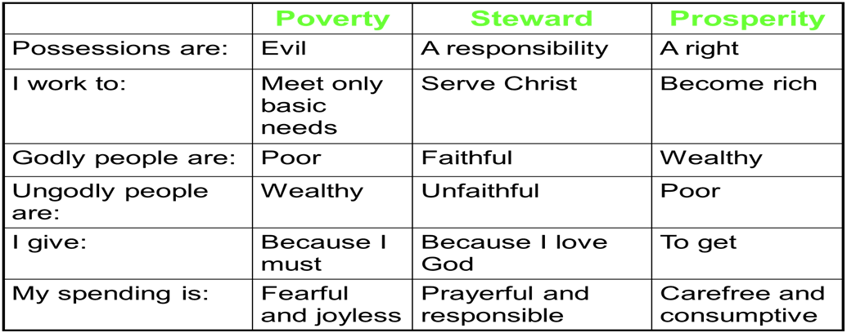

FUNDRAISING AS MINISTRY
Tom McCabe
Understanding the Ministry of Fundraising
Read 1Kings 17

Seven Key Characteristics of Fundrasing Practiced as Ministry
Dr. Thomas Jeavons and Dr. Rebekah Basinger
Result of Study of Organizations with Successful Fundraising Programs

The necessary conditions are:
- The organization and fundraising program operate with an assumption of the abundance of God’s resources and grace.
- The organization and program hold a wholistic perspective on God’s work, recognizing the need and value of a variety of ministries.
- The organization and program have a clarity about the essential theological tenets of their own tradition as those should shape their work
- The fundraising program operates in a culture of ministry where embodying the faith tradition in service to others is at the heart of the organization’s culture.
- The organization and development program make giving donors opportunities for the participation in the ministry (as far as it is possible) a major commitment.
- The organization recognizes the importance of integrated planning and includes the development program in the process of shaping larger goals.
- The development program has spiritually mature, theologically reflective leadership.

DEFINITIONS

Development describes the fundraising program of an organization. It is a term coined by Ernest DeWitt Burton, President of University of Chicago in 1924.

Fundraising is the act of requesting a gift or a grant form an individual, a corporation, a foundation, or some other source. It is a singular act—repeated many times.

Advancement refers to the administrative functions that include public relations, development, donor relations, alumni relations, and publications. Advancement is broader than development

Strategic Planning Review
Learning Tasks
- Know what are the pre-requisites for fundraising
- Review strategic planning process
- Apply strategic planning for fundraising
- Learn how to prepare a case statement

Prerequisites to resource development (fundraising)
- Institutional Readiness (VMG + SLRP)
- Trustee Leadership
- Presidential Involvement

VISION-MISSION-GOALS

VISION
Answers the question: What do you want to create?
- shared hopes
- dreams
- images of the future
Evaluate the vision of your organization
- Is it powerful?
- Can you relate to it and work hard to achieve it?
- Does it capture the image of the future?
- Does it inspire performance?

VISION-MISSION-GOALS
- Vision without action is merely a dream;
- action without vision is merely passing the time.
- Without vision people perish.

VISION STATEMENT
A Few Powerful Examples
“A computer on every desk and in every home, all running on Microsoft”—Bill Gates
“Quality is Job 1”—Ford Motors
“Guaranteed overnight delivery.”—Federal Express

MISSION
Mission is the r’aison d’etre of your organization
It answers the question: “Why do we exist?”

A good mission statement is:
- Clear and understandable
- Expresses the organization’s reason for being
- Specifies the purpose of your organization
- Is broad enough for flexibility but not too broad to lack focus
- Serves an energy source and a rallying point for the organization

Create a mission statement
- State the higher purpose of the organization that will motivate everyone
- Describe what the organization should achieve so that progress toward the higher purpose can be measured
- A clearly developed mission statement sets institution apart from others
- Distinguish the organization from other organizations in the same field
- Paint a picture of the organization’s future that all groups in the organization can support enthusiastically

GOALS
GOALS--means to achieve the mission and vision; shapes the targets towards which plans and actions are directed
- Specific — what is required is clearly stated
- Measureable — results are quantifiable
- Attainable — targets are realistic
- Relevant — goals have impact on your Key Result Areas (KRAs)
- Time bound — a clear time frame is defined
CORE VALUES — provides guiding lights, ways of choosing among competing priorities and guidelines about how people will work together

Prerequisites to resource development (fundraising)
- Once the institutional strategic plan has been developed fundraising plans can be developed
- Fundraising is not a function in itself but a method of helping the institution to achieve its plans and objectives
- Fundraising plans will be based on the strategic long-range plan

Development is anchored on the vision and mission of the organization.


Vision
Development Plan
Mission

Communicating Your VMG
- Who are you serving?
- Who are your constituents*
- Who are your publics
*Constituency map

Developing a Constituency
Communicating Your VMG
- The president articulates the vision, mission
- The president must be able to clearly articulate the institutional mission in order to cultivate support
- The constituents revise, review the vision, mission
- The constituents own the VMG for it to be effective
- VMG widely circulated by means of institutional publications
- Successful fundraising does not occur without a clearly developed mission statement

Strategic Planning for Resource Development

What is Planning?
- Your plans express dependence on God
- A clear vision, mission lead to clear goals for the institution and fundraising endeavors
- Vision
- Mission
- Objectives

Create a mission statement
- State the higher purpose of the organization that will motivate everyone
- Describe what the organization should achieve so that progress toward the higher purpose can be measured
- A clearly developed mission statement sets institution apart from others
- Distinguish the organization from other organizations in the same field
- Paint a picture of the organization’s future that all groups in the organization can support enthusiastically

How can this mission statement have an impact on fundraising?
- Prevents fundraising for the “wrong” organization
- Provides fundraisers with a “unique selling proposition” (USP)

Identify the driving force
- The driving force is the major capability or activity of an organization that will help it accomplish its mission and distinguish it from other organizations in the same field
- Driving force model

DRIVING FORCE MODEL

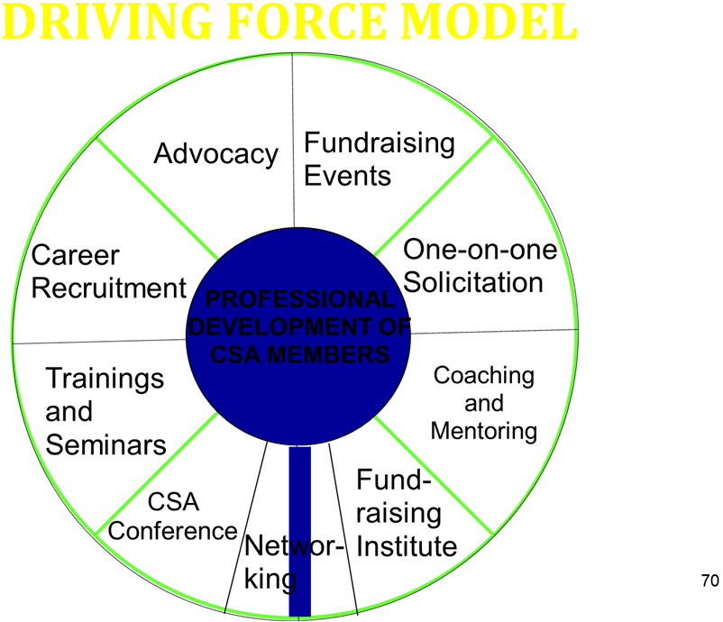

Assess strategic strengths and weaknesses
- What can make the fundraising plan succeed or fail?
- Helpful Tool: Fishbone analysis
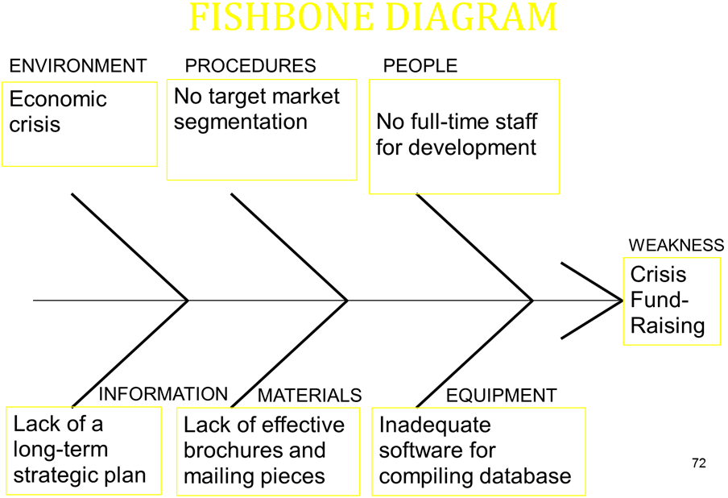

Formulate goals and strategies to achieve goals
- Goals must be SMART
- Specific
- Measureable
- Attainable
- Relevant (KRA’s)
- Time-bound
- A strategy is a major action to achieve a goal

Examples of strategies
- Annual Fundraising goal to raise P1M
  - Identify new sources of funds
  - Develop a direct mail campaign
  - Establish a new group of donors
- Gift Range Chart
Consider threats and opportunities
And revise plans accordingly
- Government regulations
- New technologies
- Changes in society’s values and preferences
- Economic realities

Develop an action plan
Action plans are specific tasks that will enable you to plan your strategies
- Be as precise and detailed as possible
- Identify who is responsible for what
- Note the date when it will be completed

Turning the 5 biggest fundraising mistakes into opportunities
- Failing to use all available resources
it is everyone’s job
recruit volunteers
- Depending on the same old fundraising events
- Targeting the same lists
- Failing to break out uses of money
- Detailed budget (how the money will be used
- Assigning the wrong people to the right job
- Before a fundraising project is assigned, an evaluation is made of the qualifications of a given person or group for the assignment

THE PLANNING PROCESS
- Where are we now?
Fundraising Assessment
l Fundraising history
l Resources
l Office/Data system
- Where do we want to be?
Strategic Choices (Growth, Involvement, Visibility, Efficiency, Stability)
l Fundraising Objectives and Goals
l Target segments
l Prospects in each segments target constituents
- How can we get there?
Organizational
l aligning the board and the team
l select vehicles
l cultivation
Departmental
l select vehicle
l staffing
l roles and responsibilities
l timelines

External
l volunteers
l public relations
4. How will we do this?
Organizational
l Fundraising plan
Departmental
l Budgeting fundraising cost
l Donation processing
l Donation acknowledgments
l Donation records
l Donation reports
l Donation systems
External
l Donor recognition
l Volunteer recognition
l Prospect research
5. How will we know how successful we are?
Organizational
l Effectiveness of programs being supported

Departmental
l Return on investment (ROI)
l Response rate
l Average donation

External
l Volunteer leaders champions
l Constituencies
CASE STATEMENT
The case statement is a cause, a clear compelling statement of all the reasons why anyone should make a contribution in support of your organization. Its purpose is to inform, inspire, excite, uplift, motivate the reader/hearer to get involved.

Questions to ask when crafting your case statement
- What is the societal need that you are responding to?
- Why do you exist?
- What is distinctive about the organization?
- What do you want to accomplish?
- How do you make yourselves accountable?

What to include in the case statement
- Mission
- Goals
- Objectives
- Programs and Services
- Staffing
- Governance
- Facilities
- Finances
- Statement of needs
- Evaluation (how accountable)
- History (accomplishments)

Eight (8) Guidelines in Case Statement Preparation
- Identify and validate the need
- Document the need
- Identify programs and strategies to address the need
- Establish the competence of the organization and the staff
- Explain who will benefit from the services that will be made possible by the financial support
- Identify the resources that are required to fund the programs
- Explain why the prospect should give
- What’s in it for the donor (what return value, spiritual return)

